Citizenship, Economics and Society (Secondary 1-3)
“3-minute Concept” Animated Video Clips Series:
“All Forms of Racial Discrimination”
Teaching Guidelines

1. Title of the animated video clip: “All Forms of Racial Discrimination”
2. Duration of the animated video clip: Around 3 minutes
3. Related CES Module: Module 1.4 Rights and Duties
4. Introduction of the animated video clip: The animated video clip was developed by the Personal, Social and Humanities Education Section, Curriculum Development Institute, Education Bureau. It uses daily examples and simple language to succinctly explain the concept of elimination of discrimination and social inclusion which included in“All Forms of Racial Discrimination”.
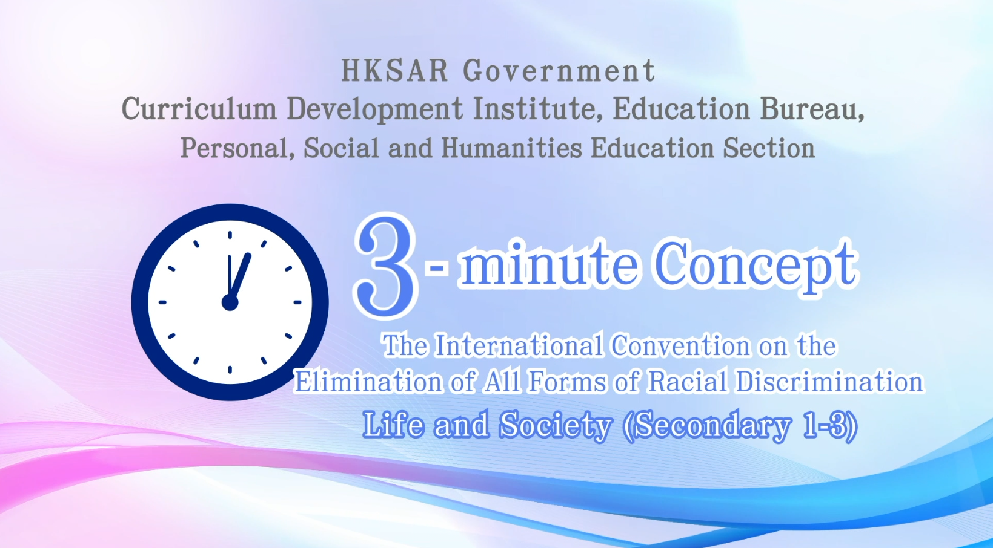
Citizenship, Economics and Society (Secondary 1-3)
Video link: https://emm.edcity.hk/media/Citizenship%2C+Economics+and+Society+%223-minute+Concept%22+Animated+Video+Clips+SeriesA+%2816%29+The+International+Convention+on+the+Elimination+of+All+Forms+of++Racial+Discrimination+%28English+subtitles+available%29/1_val6diaa
5. Teaching tips: Teachers must explain the following main points to students after playing the “All Forms of Racial Discrimination” animated video clip:
1) The Basic Law prescribes how international agreements apply to the HKSAR | Teachers should point out to students that according to Article 153(1) of the Basic Law, “The application to the Hong Kong Special Administrative Region of international agreements to which the People’s Republic of China is or becomes a party shall be decided by the Central People’s Government, in accordance with the circumstances and needs of the Region, and after seeking the views of the government of the Region.” Teachers may further point out to students that before resuming the exercise of sovereignty over Hong Kong, the Chinese government informed the Secretary-General of the United Nations in writing that the International Convention on the Elimination of All Forms of Racial Discrimination (ICERD) would continue to apply to the HKSAR with effect from July 1, 1997. This reflects that the ICERD applies to Hong Kong under the authorisation of the Chinese Government.
2) The Race Discrimination Ordinance and related legal liabilities | Teachers should point out to students that Hong Kong is an international city that respects the rule of law, equality and freedom, and that any behaviours involving discrimination against others will likely break the law and be subject to legal liability. Teachers should further point out to students that in the current anti-discrimination laws in Hong Kong, the Race Discrimination Ordinance makes it unlawful to discriminate, harass and vilify a person based on race. [# A person's ‘race’ means the race, colour, descent, national or ethnic origin of a person].  Teachers should help students understand the important messages contained in the relevant international agreements (e.g., equal rights and opportunities, the elimination of prejudice and discrimination, special care and assistance, etc.) so as to develop students’ positive values such as equality and care for others. Students are not required to rote memorise the content of the provisions. Therefore, teachers should not directly teach the provisions of the international conventions word for word in class, nor should they require students to memorise them.  Teachers can refer to the following resources:  Race Discrimination Ordinance  https://www.elegislation.gov.hk/hk/cap602!en?INDEX_CS=N  Equal Opportunities Commission – Race Discrimination  https://www.eoc.org.hk/en/discrimination-laws/race-discrimination
3) The functions of the Equal Opportunities Commission in eliminating racial discrimination | The Equal Opportunities Commission (EOC) is a statutory body responsible for implementing and enforcing four anti-discrimination ordinances in Hong Kong: the Sex Discrimination Ordinance, the Disability Discrimination Ordinance, the Family Status Discrimination Ordinance, and the Race Discrimination Ordinance. Through handling complaints related to racial discrimination, conciliating disputes, representing victims in court, conducting empirical research and policy advocacy related to racial discrimination, and arranging corporate training and public education, the EOC strives to dismantle racial prejudice and discrimination in the community and promote the values of equality, diversity and inclusiveness. For details of the functions of the EOC, please refer to the following resource:  Equal Opportunities Commission – About the EOC  https://www.eoc.org.hk/en/about-the-eoc/introduction-to-eoc
4) Elimination of racial discrimination depends on the concerted efforts of society | Teachers should point out to students that apart from the government, private sectors and the community have different roles and responsibilities in eliminating racial discrimination. Teachers are suggested to explain to students how individuals can respect and accept people of different races and how they can actively assist them in integrating into society to promote social harmony. The private sector also has a social responsibility to eliminate racial discrimination. For example, employers should ensure equal employment opportunities during recruitment and employ people based on talents and knowledge instead of turning down candidates just because of their race. Furthermore, the community should pay more attention to the living conditions of different races in Hong Kong to build a diversified society with respect, tolerance and care.

6. Consolidation questions: (See next page)

“3-minute Concept” Animated Video Clips Series:

“The International Convention on the Elimination of

All Forms of Racial Discrimination”

Worksheet

A. Multiple Choice Questions
Circle the correct answers.
- Racial discrimination means treating someone less favourable or even unequally because of their race, ____________________________.
  - colour
  - nationality
  - religion
  - age

- ii
- i, ii
- i, ii, iii
- i, ii, iii, iv
Ans: C

- The main principles of ICERD include:
  - respect for the dignity inherent in all people
  - equality
  - protection of basic human rights and freedoms
  - provision of special care and assistance to those in need

- i, iii
- ii, iv
- i, ii, iii
- i, ii, iii, iv
Ans: D

- According to the Race Discrimination Ordinance, which of the following is unlawful?
A. It is unlawful to discriminate, harass or vilify a person on the ground of his/her race in prescribed areas of activities.
B. It is unlawful to discriminate against a person on the ground of sex, marital status, pregnancy or breastfeeding in prescribed areas of activities.
C. It is unlawful to discriminate against a person on the ground of disability when committed in prescribed areas of activities.
D. It is unlawful to discriminate against a person on the ground of family status.
Ans: A

- When getting along with people of different races, what should we do?
  - We should pay attention to and reflect on whether we have any stereotypical views of, or prejudices against, people of other races.
  - We should learn more about the lifestyles and traditional customs of people of different races.
  - We should show respect for their ways of life, languages and customs.

- i
- ii
- ii, iii
- i, ii, iii
Ans: D

B. True or False
Study the following sentences about the International Convention on the Elimination of All Forms of Racial Discrimination. Put a “T” in the blank for correct description and an “F” for incorrect description.
 | The International Convention on the Elimination of All Forms of Racial Discrimination aims to encourage understanding, inclusiveness and respect among different ethnic groups so that everyone can be treated equally. | T
 | The International Convention on the Elimination of All Forms of Racial Discrimination continues to apply to the Hong Kong Special Administrative Region effective from 1 July 1997. | T
 | Office of the Privacy Commissioner for Personal Data is responsible for monitoring the implementation of the Race Discrimination Ordinance. | F

C. Short Question
How can we work towards racial inclusion in our daily lives?
We should learn to understand people of different backgrounds, avoid
making uninformed judgments or focusing solely on own culture and
perspectives, and should treat everyone with equality, appreciation and
respect to achieve true inclusiveness.

 The End 

